PROGRAMING FUNDAMENTAL (theory)

A.HANNAN
SU92-BSSEM-177

TASK 1:

#include <iostream>
using namespace std;

int calculate2Low(int arr[], int n)
{
for(int i=0;i<n-1;i++)
{
for(int j=i+1;j<n;j++)
{
if(arr[i]>arr[j])
{
int temp=arr[i];
arr[i]=arr[j];
arr[j]=temp;
}
}
}
return arr[1];
}

int calculate2High(int arr[], int n)
{
return arr[n-2];
}

int main()
{
int n;
cin>>n;

int arr[100];

for(int i=0;i<n;i++)
{
cin>>arr[i];
}

cout<<"2nd Lowest: "<<calculate2Low(arr,n)<<endl;
cout<<"2nd Highest: "<<calculate2High(arr,n);

return 0;
}
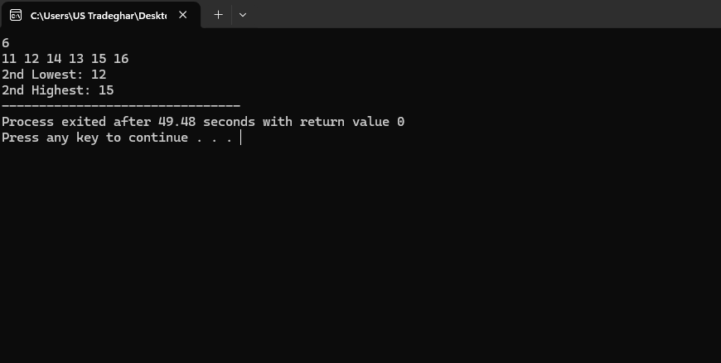
TASK 2
#include <iostream>
#include <iomanip>
using namespace std;

double calculateSum(int arr[], int n)
{
double sum=0;

for(int i=0;i<n;i++)
{
sum=sum+arr[i];
}

return sum;
}

int main()
{
int n;
cin>>n;

int arr[100];

for(int i=0;i<n;i++)
{
cin>>arr[i];
}

cout<<fixed<<setprecision(2)<<calculateSum(arr,n);

return 0;
}
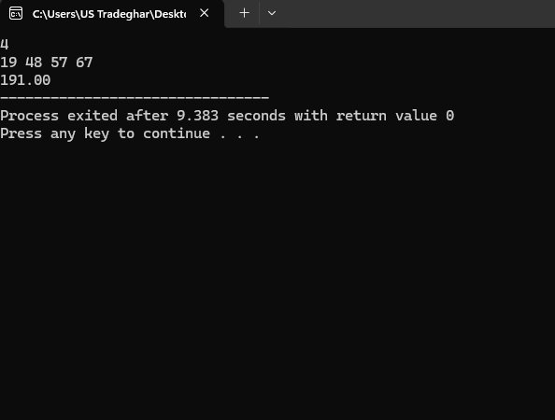

TASK 3

#include <iostream>
#include <iomanip>
using namespace std;

double celsiusToFahrenheit(double c)
{
return (c*9/5)+32;
}

int main()
{
double c;
cin>>c;

cout<<fixed<<setprecision(1)<<celsiusToFahrenheit(c);

return 0;
}
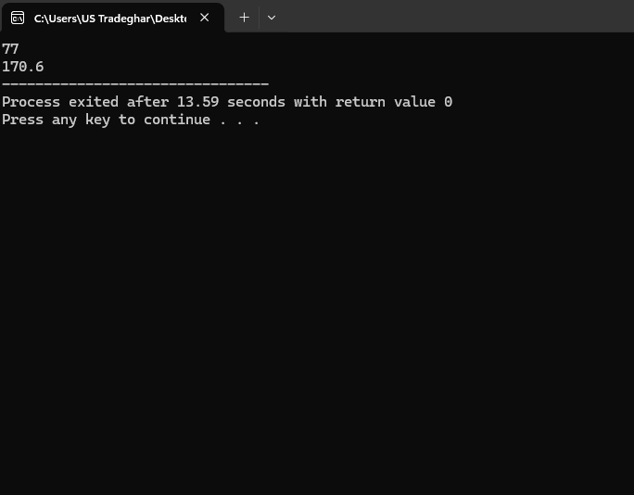

TASK 4
#include <iostream>
using namespace std;

bool isLeapYear(int year)
{
if(year % 400 == 0)
{
return true;
}

if(year % 4 == 0 && year % 100 != 0)
{
return true;
}

return false;
}

int main()
{
cout << isLeapYear(2024);

return 0;
}
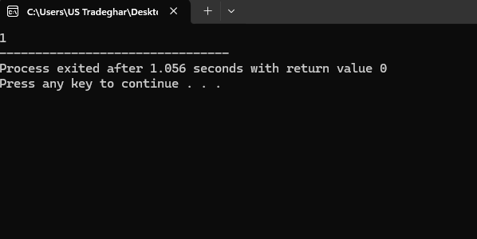
TASK 5
#include <iostream>
using namespace std;

int countVowels(char word[])
{
int count = 0;

for(int i = 0; word[i] != '\0'; i++)
{
if(word[i]=='a' || word[i]=='e' || word[i]=='i' || word[i]=='o' || word[i]=='u' ||
word[i]=='A' || word[i]=='E' || word[i]=='I' || word[i]=='O' || word[i]=='U')
{
count++;
}
}

return count;
}

int main()
{
char word[100];

cin >> word;

cout << "Total Vowels: " << countVowels(word);

return 0;
}
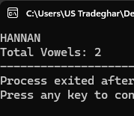
TASK 6
#include <iostream>
using namespace std;

int main()
{
char arr[5];

for(int i = 0; i < 5; i++)
{
cin >> arr[i];
}

for(int i = 0; i < 4; i++)
{
for(int j = 0; j < 4 - i; j++)
{
if(arr[j] > arr[j + 1])
{
char temp = arr[j];
arr[j] = arr[j + 1];
arr[j + 1] = temp;
}
}
}

cout << "Sorted Letters: ";

for(int i = 0; i < 5; i++)
{
cout << arr[i] << " ";
}

return 0;
}
